Duquesne University

Etienne H Kahe

Instructor: Darren Marriano

July 24, 2008

Comparison Chart & costs
 | Lenovo ThinkPad X300 http://shop.lenovo.com | Inspiron 1420  http://www.dell.com | Compaq Presario C700T  http://www.notebookreview.com/default.asp?newsID=4202
Speed/Processor | Intel Core 2 Duo SL7100 processor with 800MH | Intel® Pentium® Dual Core T2390 (1.86GHz/533Mhz FSB/1MB cache) | Pentium(R) Dual-Core Mobile Processor T2370 (1.73 GHz)
Case/Tower | Laptop case | Laptop case | laptopcase
Operating System | Windows Vista Business Edition | Genuine Windows Vista® Ultimate Edition SP1 | Windows Vista Home Basic with Service Pack 1
File System | NTFS | NTFS | NTFS
Cache | Type: L2 cache Installed Size: 4 MB | 1 MB L2 | 2MB L2
RAM | 1 gig DDR2 RAM | 1GB² Shared Dual Channel DDR2 at 667MHz | 1GB DDR2 System Memory (2 Dimm
Hard Disk | 64 gig SSD (solid state drive) | Size: 120GB³ SATA Hard Drive (5400RPM) | 160GB 5400RPM SATA Hard Drive
USB 2.0 | 3 ports | 4 ports | 3 ports
Firewire IEEE 1394 | 2 | 2 | 1
PCI slots | 3 | 3 | n/a
Sound Card | Audio Output: Sound card Audio Codec: AD1984A Compliant Standards: High Definition Audio Input: Microphone | High Definition Audio 2.0 | Integrated High Def. Audio Realtek ALC655
Video/ Graphics Card | Intel GMA X3100 Dynamic Video Memory Technology 4.0 | Intel Graphics Media Accelerator X3100 | Intel(R) Graphics Media Accelerator X3100
CDRW/DVD Drive | CD-RW/DVD-ROM 24x/24x/24x/8x Max Combo Ultrabay Enhanced | CD / DVD writer (DVD+/-RW Drive) | LightScribe SuperMulti 8X DVD+/-RW with Double Layer Support
Floppy Disk Drive | no | no | n/a
Network Card | Integrated Intel Wi-Fi Link 4965AGN Wi-Fi 802.11a/b/g/n | Dell Wireless 1395 802.11g Mini Card | 802.11b/g WLAN
Speakers | Built in stereo speakers, mic and 3.5mm standard stereo headphone jack and mic jack. | Built in stereo speakers, mic | Built in stereo speakers, mic
Mouse | Optical USB | Optical USB | 2 button USB Optical
Keyboard (Multimedia) | multimedia | multimedia | 104+ USB
Warranty/Service | 1Year Depot Warranty | 1Yr Ltd Warranty⁴ and Mail-In Service | 4 yr
Microsoft Office | Microsoft 2007 Professional Academic price$159.99 | Microsoft 2007 Professional Academic price$159.99 | Microsoft 2007 Professional Academic price$159.99
Monitor | 13.3", 1440 x 900 pixel resolution | Glossy, high contrast, widescreen 14.1 inch display (1280x800) | 15.4" diagonal WXGA High-Definition HP BrightView
Cost | $3,600.00+159.99(M.office) | $1223+159.99(M.office) | $ 664.99
Cost for 20 Machines | $75,199.80 | $27,659.80 | $13,299.80
Color Printer | Dell Color Laser 5110cn  $1,354.00 | HP Color LaserJet 3600 Printer series  $ 399.00 | Panasonic KX-MB781 All-in-One Network Laser Printer
Printer Cables | 1 - Dell USB 2.0 Printer Cable 10’ ($24.95) | 1 - Hp USB 2.0 Printer Cable 2m ($16.00) | Cable included
Cost for Printer | $1,378.95 | $415 | $229.99
Scanner | Canon- Scan Front 220P Network Scanner  $1,769.99 |  | Included in Printer)
  Kodak Scan Station 100 - 10Base-T/100Base-TX
  $1,804
Cost for Scanner | $1,769.99 | $1,804 | included
Server Type | Thinkmate Intel Rackmount Servers XF3-1100 | DellTM PowerEdgeTM 2900 III 2-socket server | HP ProLiant DL 700
Server Cost | $899.00 | $7056 | $16,999.00
Network | 24 port, all-Gigabit, fully managed switch.  $2,372.00 | Cisco 24-Port Catalyst 2950 10/100 Catalyst Switch WS-C2950-24  $2,372.00 | HP 24 Port 10/100/1000 w/2 Mini GBI Ports Unmanaged Switch  $246.04
Network Cable | 20-CAT5 Cables (9.95 each)  $199 | 20-CAT5 Cables (9.95 each)  $199 | 20-CAT5 Cables (9.95 each)  $199
Network + cable | $2,570.05 | $2571 | $445.04
TOTAL COST | $81,818.74 | $39,505.80 | $30,973.83
Notes: This total does not include additional software and hardware for the lab
Additional software:
LangLab PASSPORT
Cost: $3,775.00
Additional hardware:
Projector: Epson PowerLite S5
Cost: $465

TV: Toshiba Large Screen TV Entertainment Center

Cost: $949.95
DVD/VCR: Samsung DVD-VR357 DVD Recorder/VCR Combo
Cost: $94.99
20-Computer headphones with microphone Robotel Elecrtrohome ($10 each)
Cost: $200
A computer-to-TV-monitor adapter:

Cost: $150

Total Additional Cost: $5,634.94
Total cost for the lab: $45,140.74

Lab Diagram

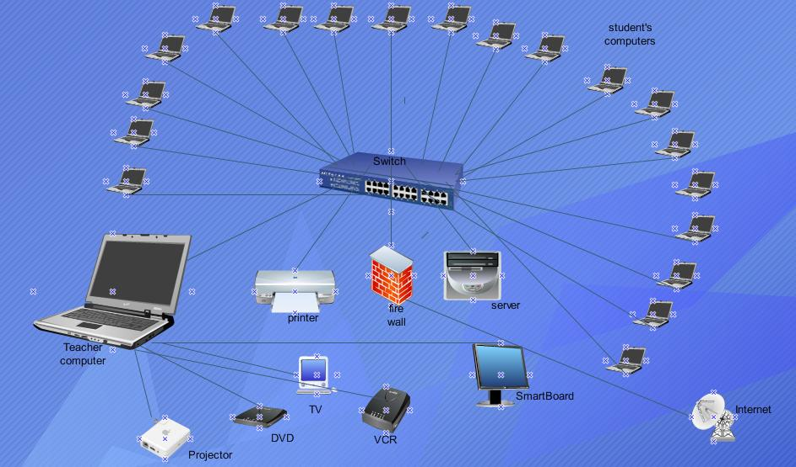

Written Proposal
Introduction
This lab proposal is concerned by any high School or Middle school with more than 50% of student population speaking English as second language. To bring these students to the same level as the Native American students, the school needs a state-of- the Art language learning lab to help the teachers. This particular scenario will happen at the Smitha Middle School located in the Coob County school District in Atlanta, Georgia. Smitha Middle School has a large students population in need of English speaking skills in order to perform well in subjects such as Math, physics, Geography, sociology etc. computer-assisted language learning can help English teachers and any other language teacher to reduce the frustration and anxiety of students and make language learning as fun as possible. Interactive computer network allows students to test the result of learning without the risk of being punished for any mistake.

Description of the lab

The lab will be set in a Star topology; the reasons of our choice rely on the many advantages of the topology:
- A low specification twisted-pair cable can be used for connection between the server and the nodes clients since data rate is relatively low between the central server and the nodes
- A fault on one of the nodes will not affect the rest of the network, as individual node failure does not affect the network.
Hardware
The network will use 19 laptops computers for students and 1 laptop for teacher station, all with the same technical specifications. The choice of laptops versus desktops came from the fact that the space allocated for the lab is better suited on the laptop form factor than a desktop form factor. We reviewed three laptops for the lab, and we chose Dell Inspiron 1420(see comparison chart).Compare to the other units, Dell Inspiron 1420 is highly configurable with plenty of networking options; discrete graphics option; excellent battery life. The screen is very spacious for a portable machine. We thought that language learning students need a spacious screen to handle multiple simultaneous tasks (Web surfing, media playback, document editing). Dell includes an industry-standard one-year parts-and-labor warranty with the system.
The server is The Intel based Dell PowerEdgeTM 2900 III. Our lab is a language learning lab but it could also help as a multipurpose lab. For that reason we needed a server that could combine maximum expandability and performance. Dell PowerEdgeTM supports most any type of application, including database, email and virtualization. PowerEdgeTM servers are the most secure severs of their generation. The optional internal tape drive allows easy backup, archive and data recovery. The PowerEdgeTM 2900 III supports RAID levels 6 and 60.The server will be used to house the student files, software and applications.
The networking capability is provided by Cisco 24-Port Catalyst 2950 10/100 Catalyst Switch WS-C2950- 24. Student’s computers and teacher station will connect to the network by the Cisco switch. We did choose this Cisco Switch for its Wire-speed, non-blocking performance on all ports, including Gigabit ports, its 8.8Gbps switching fabric and 6.6 million packets-per-second maximum throughput.
A network Printer (HP color LaserJet3600) is connected to the network thru the Cisco switch.
For delivery performance the teacher’ station is able to connect to DVD/VCR combo, a projector, or a smart board.
The language lab minimizes the scan jobs in this setting, the scanner will not be a network scanner but a stand-alone scanner to handle the few scanning jobs we may face.
Software
Microsoft Office professional: The student’s computers and the teacher computer are equipped with Microsoft office 2007 for any needed editing work.
Microsoft window Vista Ultimate: Computing and networking purposes, all the machine are equipped with a genuine version of Microsoft window Vista Ultimate
LangLabPassport: The teacher’s station is equipped with LangLab Passport, language learning software the teacher will use to plan, assemble, and deliver lessons using audio, video, images, and text.

Children Information Protection Act

Smitha Middle School is part of the Cobb county School district. Our Internet is provided by the school district; therefore the internet filtering is done thru the proxy protection server of the school district.

Policies for using the lab
(Please follow these policies when using the lab to complete assignment)

Rule1: code of conduct
The purpose of the lab is for language teachers to deliver their lessons with appropriate technology and for students to complete computer-based coursework and assignments. Any conduct or activity which disturbs the lab environment is not allowed. Anyone causing a continual disturbance will be asked to leave the labs.
Rule2: closing: When the lab is used by student only, to complete assignments, Printers are turned off 15 minutes before the lab closes, and All Students must leave the lab when directed by a Student Assistant
Rule3: Disks and Thumb Drives
Student must bring their own diskettes and/or thumb drives if needed. Thumb drives can be plugged in to the USB ports in the front of the machine or on the side.

Rule4: Equipment
- Only authorized technicians are allowed to make modifications to lab equipment.
- Please do not unplug any wires from the machines
- Scanners, mice, keyboards, etc. are not allowed to be moved.
- No other device may be plugged into the network or electrical outlet
- Changes to software configuration or installation of new software is restricted
Rule5: Food & Drink
- Food and drink are not allowed in the labs.
- Any food or drink brought into the lab must be in a sealed container and kept in your bag.
- Eating and drinking in the labs is prohibited
Rule6: Behavior
Persons exhibiting hostile or threatening behavior such as yelling, swearing, or disregarding requests made by lab personnel will be asked to leave the labs
Rule7: Noise
- Any activity which causes enough noise to be disturbing the other students working in the labs must be discontinued or corrected.
- Please keep all voices down so as to not disturb students working in the labs.
- Everyone must use headphones when listening to sounds on the computers.
- Cell phones are not allowed to be used within the labs.

References

Compaq Presario C700T @
http://www.notebookreview.com/default.asp?newsID=4202
Dell computers@ http://www.dell.com

EDraw Network Diagramer @ http://edraw-net-diagram.qarchive.org/
LangLab PASSPORT@ http://www.langlab.co.uk/passport_live.html
Lenovo ThinkPad X300 @ http://shop.lenovo.com
Microsoft@ www.microsoft.com
Smitha Middle school @ http://www.cobb.k12.ga.us/~smitha/Welcome%21.html

